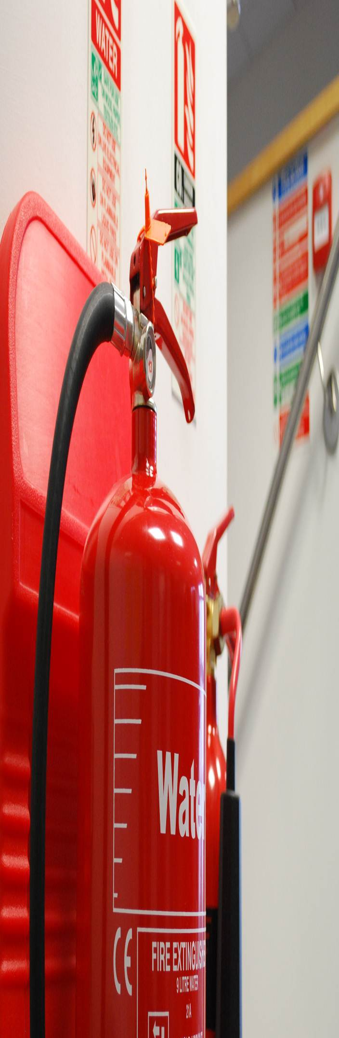
Name of Home
Smoking Fire Risk Assessment
Residential Care Homes
(Revision 02)

Name of Resident: Click here to enter text.
Residents Bedroom Number & Floor Level: Click here to enter text.
Date of Assessment: Click here to enter a date.

Prepared By:

Marpal House
Wyvern Court
Stanier Way
Wyvern Business Park
Derby
DE21 6BF
Tel: 01332 668 877
Fax: 01332 660 077
E-mail: info@marpal.co.uk
Website: www.marpal.co.uk

Building and Person Centred Fire Risk Assessments

There are two essential aspects to consider when carrying out Fire Risk Assessments:-

- An assessment considering the building and the management and maintenance there of
- The needs and risk associated with the people occupying the building.

Smoking Fire Risk Assessments

The actions and activities of individuals can not only impact upon the safety of the individual, but also upon the safety of others. A relatively high proportion of recent fires within Care Homes have involved residents who smoke (both traditional smokers and those who use e-cigarettes). Home Managers may not be aware of all the potential fire safety risks, hence, the completion of a comprehensive standardised template is essential for reducing risks to a minimum.

The Building’s Fire Risk Assessment

The Home’s Fire Risk Assessment looks at the measures in place to help prevent a fire starting in the first instance, ensure that suitable measures are in place to reduce the spread of fire and smoke in the event of a fire and also to ensure that residents can escape from the effects of fire and smoke, without suffering harm.
The Smoking Fire Risk Assessment and the building’s Fire Risk Assessment go hand in hand, both can be ineffective without the other being in place.

For further assistance on Smoking Fire Risk Assessments and the Building’s Fire Risk Assessment, please contact Adrian Gouldin by phone (01332 668 877) or email (agouldin@marpal.co.uk).

Smoking Fire Risk Assessment - Residential Care Homes

Section 1 - Assessment Details

Name of Care Home:- |  | Name of Resident:- | Click here to enter text.
Residents’ Bedroom Number, Unit and Floor Level:- | Click here to enter text. | Date of Taking up Residency:-
Name of Assessor:-  (Home Manager) |  | Date of Assessment:- | Click here to enter a date.

Notes
Care Home providers and their staff have a responsibility to look after the health & safety of all of the residents in their care; this Smoking Fire Risk Assessment is intended to assist in the discharging of these responsibilities.

This Smoking Fire Risk Assessment should be completed by the Home Manager and if necessary, with the assistance of a Senior Nurse.

It is envisaged that, the Smoking Fire Risk Assessment will be initially completed immediately prior to the resident taking up occupancy and thereafter be updated:-

- At or around 14 days after taking up residency at the Home (once the Home Manager and staff have got to know the resident).
- Following a change in the residents’ health, mobility, medication or general behaviour.
- Following a change to the physical smoking arrangements at the Home.
- On an ongoing basis every 6 months.

Section 2 - Building Specific Issues

Ref | Item |  | Response |  | Action to be taken
2.0 | Physical Arrangements at the Home
2.1 | Type of smoking area for residents use:- |  | Choose an item. |  | Choose an item.
2.2 | Ventilation of smoking area:- |  | Choose an item. |  | Choose an item.
2.3 | Floor covering within internal smoking area:- |  | Choose an item. |  | Choose an item.
2.4 | Flooring material within the external smoking area:- |  | Choose an item. |  | Choose an item.
2.5 | Combustible materials within or around the smoking area:- |  | Choose an item. |  | Choose an item.
2.6 | Furniture within smoking area:- |  | Choose an item. |  | Choose an item.
2.7 | Location of the smoking area:- |  | Choose an item. |  | Choose an item.
2.8 | Combustibility of materials within residents bedrooms:- |  | Choose an item. |  | Choose an item.
2.9 | Highly combustible materials:- |  | Choose an item. |  | Choose an item.
2.10 | Disposal of smokers’ waste material:- |  | Choose an item. |  | Choose an item.
2.11 | Portable fire firefighting equipment:- |  | Choose an item. |  | Choose an item.
2.12 | Airflow mattresses:- |  | Choose an item. |  | Choose an item.
2.13 | Charging of e-cigarette batteries:- |  | Choose an item. |  | Choose an item.

Section 3 - Resident Specific Issues

Ref | Item |  | Response |  |  | Action to be taken
3.0 | Residents Wishes
3.0.1 | Does the resident wish to stop smoking? |  | Choose an item. |  |  | Choose an item.
3.1 | Type of Smoking Products Used
3.1.1 | The resident prefers to smoke using:- |  | Choose an item. |  |  | Choose an item.
3.1.2 | Method of igniting cigarettes:- |  | Choose an item. |  |  | Choose an item.
3.1.3 | Condition of cigarette lighters:- |  | Choose an item. |  |  | Choose an item.
3.2 | Residents’ Care/Medical Needs
3.2.1 | For day to day mobility purposes, the resident:- |  | Choose an item. |  |  | Choose an item.
3.2.2 | The residents’ mental health:- |  | Choose an item. |  |  | Choose an item.
3.2.3 | Medical conditions/history:-  Choose an item.  - Seizures  - Strokes  - A heart condition  - Epilepsy  - Narcosis  - Parkinson’s disease  - Muscle weakness  - Paralysis  - Lack of smell  - Sight impairment  - A condition that may affect their ability to smoke safely. |  | Choose an item. |  |  | Choose an item.
3.2.4 | Deteriorating health:- |  | Choose an item. |  |  | Choose an item.
3.2.5 | Medication being taken:- |  | Choose an item. |  |  | Choose an item.
3.2.6 | Use of emollient creams:- |  | Choose an item. |  |  | Choose an item.
3.2.7 | Use of oxygen:- |  | Choose an item. |  |  | Choose an item.
3.2.8 | Residents’ fire safety history:- |  | Choose an item. |  |  | Choose an item.
3.3 | Residents’ Care/Medical Needs
3.3.1 | Evidence of burn marks in bedroom:- |  | Choose an item. |  |  | Choose an item.
3.3.2 | Evidence of burn marks in smoking area:- |  | Choose an item. |  |  | Choose an item.
3.3.3 | Evidence of smoking within bedrooms or bathrooms:- |  | Choose an item. |  |  | Choose an item.
3.3.4 | Evidence of burn marks on resident or on resident’s clothes:- |  | Choose an item. |  |  | Choose an item.
3.3.5 | Level of risk to resident and others:- |  | Choose an item. |  |  | Choose an item.

Section 4 - Summary of issues identified and action to be taken
Choose an item.
Section 7 – Summary of Overall Risk

Based on the information gathered about the residents’ health and mobility, the Home Manager is required to make an evaluation of risk using the following definitions and placing a cross in the low, medium or high box.

Low Risk:- The resident is considered competent to smoke with little or no assistance from staff.

Medium Risk:- The resident is at risk of igniting either their clothing or other materials whilst smoking and requires staff assistance when smoking.

High Risk:- The resident requires a high level of staff assistance and needs to have additional safety arrangements in place prior to smoking.
 | Low | ☐ | Medium |  |  | ☐ | High | ☐
Home Manager’s Signature: |  |  |  | Print Name: |  |  |  |  | Date:

Please note that this Smoking Fire Risk Assessment only forms part of the overall Fire Risk Assessment, the building and its management systems must also be Fire Risk Assessed.

